CONTRAST

Contrast refers to differences in …
VALUES – COLORS – TEXTURES – SHAPES and other elements

Contrasts create visual excitement and add interest to the work.
If all the art elements – Value, for example are the same, the result is monotonous and unexciting

Learning Link; https://youtu.be/l5Q52qe9mUI
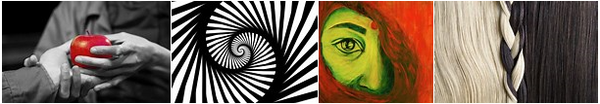

Include a minimum of 3 examples: Light & Dark

Warm & Cool

Pattern & Solid

Rough & Smooth

Bright And Dull

Small & Big

